Pinduoduo (PDD): Business Model
When Pinduoduo launched in 2015, there was little room for a new e-commerce platform in China. Two major e-commerce platforms JD and Taobao/TMall (sub brands of Alibaba) dominated the online commerce in China, much like Amazon dominates in the US. During that same year, JD and Taobao generated a combined $433B of gross merchandise value. And yet, five years later, Pinduoduo is defying expectations, skyrocketing from a start-up to a 57-billion-dollar-company with an active buyer base of 585 million that generated over $144B of Gross Merchandise Value in the past 12 months. In 2020, it is China’s second largest e-commerce platform on an active user basis after Alibaba.

Pinduoduo found room in e-commerce, not as a competitor to search-based websites like JD, but as a new e-commerce platform focused on interactive and social shopping experiences online. Social shopping may seem like a new concept, but the reality is that in the physical world, shopping is meant to be “interactive and fun”, and shoppers are regularly informed by friends and family. Consider how much harder it feels to purchase a new clothing item without immediate feedback from friends. E-commerce platforms like JD, Alibaba and Amazon don’t account for this. Instead, they optimize for efficiency, funnel conversion and purchase rates. Pinduoduo, on the other hand, has tried to mimic the offline shopping experience online by building community via their team purchase model, driving engagement via fun and interactive games and rewards, and offering personalized experiences and value via recommendations.
Consumers’ desire for social engagement while shopping is highlighted by sales within categories. Only 29 percent of apparel, 11 percent of health and personal care, and 3 percent of food & beverage purchases were expected to happen online in 2020 in the US (compared to 55 percent and 43percent of books/music and computers/electronics purchases, respectively). These numbers reveal a missing element in the e-commerce. Social shopping is particularly important for categories where consumers seek feedback or recommendations from friends. Pinduoduo is one of the first companies to successfully create a social shopping experience online, and it has accelerated the transition of commerce from offline to online in China.
In our view, Pinduoduo’s rapid success in social commerce will be replicated by others companies globally, which will continue to drive commerce in the social-driven categories online. And so, to understand the success of Pinduoduo is to understand the future of global e-commerce.

Creating Community via Team Purchase

The core of the Pinduoduo experience is team purchase, where buyers form a group in order to receive discounts from suppliers. The user experience, as laid out in the graphic below, is as follows: (1) for each item, merchants decide two prices—one for individual purchase and one for team purchase. If the user opts for a team purchase, he or she may either (2.1) initiate a team purchase or (2.2) join an existing team purchase. If the user has initiated a team purchase, he or she may use social platforms such as WeChat to proactively encourage friends to join their team (3.1) or more passively wait for other buyers to join the purchase on the Pinduoduo platform (3.2). A team needs to be formed within 24 hours to have the order confirmed. Once the team is formed, the purchase is confirmed, and the product is shipped within 48 hours.

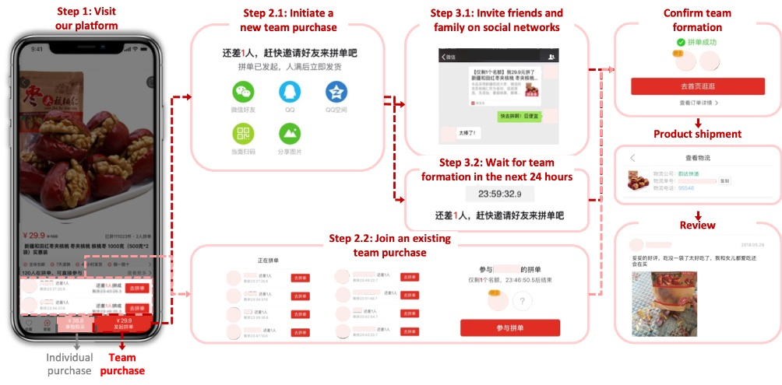
Nearly all Pinduoduo transactions are completed using team purchase. In the early days, the size of many groups was large (e.g., 10+), but as Pinduoduo has scaled, the group size requirements have declined. Team purchase is beneficial to both buyers and manufacturers; buyers benefit from better prices for goods they want, and sellers benefit from increased demand and better visibility of future demand. In addition to driving down prices, team purchase helps solve the “trust deficit” of retail in China’s developing cities, where more than 80 percent) of retail is unorganized and consumers rely heavily on social recommendations to initiate transactions.
Pinduoduo’s team purchase is often compared to Groupon in the US because they both enable a form of group buying. But the models are actually very different. First, Pinduoduo deals are designed by sellers, but initiated by consumers (i.e., users must create or join a group of a certain size to access a deal), whereas Groupon deals are designed and managed by sellers. Second, Pinduoduo’s team purchase is used for everyday goods (e.g., fruits/vegetables, apparel) that are valuable to consumers vs one-off products/experiences that haven’t sold well elsewhere. Third, products on Pinduoduo are offered by geographically diverse merchants from across China and increasingly from all over the world. This is in contrast with Groupon where mostly the local sellers have leverage to drive customers to their stores/locations. This results in a much stronger consumer value proposition as users are getting discounts on goods that they might need to purchase anyway vs letting sellers dictate discounts by aggregating demand on low-value goods or excess inventory.
To maximize this effect, Pinduoduo launched in the fruits and vegetables category. This was strategic for two reasons: 1) incumbents were focused on non-perishable items, so competition was limited and 2) fruits and vegetables have lower order value but are high frequency goods, which means users had a reason to use Pinduoduo regularly. When potential buyers saw a great deal, they would forward it to their neighbours and friends via WeChat to create a team of 10+ buyers to be able to purchase the product. In return, the group initiator would get produce for free as they helped Pinduoduo acquire 10 incremental users. Because team purchase drove organic sharing of the product, Pinduoduo was able to grow its user base very quickly. Only one month after launching their first party application in January 2016 (transactions prior to this happened via WeChat), Pinduoduo already had over 10 million customers. Only four years later, Pinduoduo has grown to 585M active buyers. To compare, Alibaba crossed the 500M active buyer threshold in 14 to 15 years after launching its consumer facing marketplace vs just four years for Pinduoduo. The take-away for startups is that the team purchase model is significant because it enables behaviours associated with offline commerce (e.g., sharing products or ideas with friends, browsing a shopping mall with friends) in an online setting. Team Purchase helped Pinduoduo grow quickly and create a unique recommendation engine based on users’ social interactions. While Team Purchase may be unique to China today, we expect social e-commerce to be global. New commerce platforms that can leverage social relationships will accelerate the offline to online transition, and if you are able to tap into groups of social relationships vs one-to-one relationship, the faster your platforms will scale. PDD has one of the most powerful network effects in the world (Reed’s law: The value of a group-forming network is proportional to number and the ease with which groups form within it. Think Slack, WhatsApp Groups -- they all grew exponentially as they could tap into groups of social relationships)
While Team Purchase was the main reason for Pinduoduo’s rapid growth, a significant enabler of Pinduoduo’s virality was the widespread use of WeChat as a platform in China. Tencent (WeChat’s owner) is a large investor in Pinduoduo, and as a result was happy to let Pinduoduo grow on top of their ecosystem. We think it is highly unlikely that Facebook would allow a social commerce application like Pinduoduo to be built on top of Messenger or Instagram in the US. That said, messaging is fragmented in the US, so this is not an issue for US-based social e-commerce companies.
Users visit Pinduoduo without any specific intent, much like visiting a real-world shopping mall. In a shopping mall, the time that a consumer spends at the mall directly correlates with the amount he or she buys. As such, Pinduoduo has gamified the experience to maximize the amount of time a user spends on the app irrespective of whether they make a purchase or not. The primary features/experiences that have incentivized sharing and usage are Daily Check-Ins, Price Cuts, Card Programs and Mini Games. Social commerce does not just mean connecting user accounts to Facebook. It means investing in creating physical world experiences online—specifically bringing the fun of shopping offline to online platforms. We will walk through how Pinduoduo has implemented this below.
Daily check-ins
The daily check-in is a feature, prominently featured in the centre of the home page. It encourages daily usage by rewarding users with redeemable points each time he or she checks into Pinduoduo. The user experience is laid out in the image below. First, the user clicks the yellow icon to administer a check-in. Each time the user checks-in, they are granted a small amount of money and/or credit. Over many months (and many check-ins), these rewards accumulate. In the example below, the user has accumulated 26.6 RMB of rewards. To cash out in the form of a no minimum spend voucher, the user has to reach a certain minimum value (i.e., 30 RMB).
The daily check-in is a simple yet brilliant feature that encourages users to engage with Pinduoduo on a daily basis. While each check-in does not generate revenue for Pinduoduo, the product experience eventually ties back to commerce if/when users redeem their vouchers. This theoretically should yield a higher customer lifetime value for Pinduoduo.
Price Chop
Price Chop is a feature that allows users to get products for free by sharing a custom link with their friends. The feature is outlined in detail below. Once in the Price Chop section of Pinduoduo, the user selects the goods that they want for free. Upon selection, a 24-hour timer begins. To get the item for free, the user must share their link with as many friends as possible. Every friend that clicks on the link and engages with Pinduoduo (no purchase required) drives an incremental discount for the initiator. If you don't reduce the price to 0 within 24 hours, you don't get the item for free, and you have to start all over again!
The product mimics the experience of “levelling” in a massive online multiplayer game like World of Warcraft, whereby it becomes harder to level up as you graduate to higher levels. In the case of Pinduoduo, the difficulty is customized based on the user (i.e., easier for low-engagement users) and the item (i.e., expensive items are more difficult to chop). Additionally, similar to levelling, as you get closer to 0 (i.e., a higher level) each incremental friend that engages with your link grants smaller and smaller discounts.
Similar to Daily Check-In, Price Chop encourages users to engage with Pinduoduo, and eventually ties the engagement to an order on the commerce platform. But unlike Daily Check-In, Price Chop incentivises users to share Pinduoduo with their social network. So, in addition to increasing customer lifetime value, Price Chop also helps Pinduoduo to efficiently acquire customers via user-user sharing of the product.
Card Program
Pinduoduo’s card program is designed to encourage users to share the product amongst friends and to save money via vouchers/special discounts. Pinduoduo has created several different cards that either (1) encourage certain user behaviours or (2) provide utility to a Pinduoduo user. The three most popular cards are the Free Pass Card, the Black Brand Card and the Brand Card.
The Free Pass Card is similar to a loyalty program where users can enjoy a “team purchase discount” without having to join a team. Users usually get one Free Pass Card after making two purchases on Pinduoduo.
The Brand Black Card encourages users to leave reviews on the platform by offering them a discount on branded products in return. Pinduoduo gives users a Brand Black Card after they have posted two to four reviews on the website. This is important as consumers rely on reviews and recommendations from previous buyers when making purchase decisions. The Brand Black Card incentivises a good user behaviour that makes the platform better for the entire user base.
The Brand Card aims to promote Pinduoduo’s branded products. Consumers get a Brand Card after they have made a purchase on Pinduoduo. They can share their brand cards with friends via WeChat to attract their friends to browse and buy branded products from Pinduoduo. It is an effective way to encourage users to buy branded products they would not normally buy because the recommendation/card was sent to them by a trusted friend.
This is also important because Pinduoduo has historically been used to primarily buy non-branded products. The Brand Card is an effective incentive mechanism to increase Pinduoduo’s branded product market share in China.
Mini Games
Pinduoduo wants users to engage with the platform as often as possible, and they want the experience to mimic real-world shopping. As such, they want users to engage with the app to have fun, even if it does not immediately translate into a purchase. Pinduoduo now hosts in-app games to help drive up daily time spent on the platform. The first popular game on Pinduoduo was Duo Duo Orchard. Think of Farmville except now the rewards are real physical goods. The game is simple—a user creates and nurtures a virtual fruit tree to eventually yield a real box of fruit shipped to his or her address. It already has more than 11M DAUs!
Though not multiplayer, Orchard has social cooperation aspects that drive up network engagement as well. Once users choose a tree to create (e.g., mango, lemon, macadamia nut), they need to nurture the tree with water and fertilizer. The more you shop on Pinduoduo the more water droplets you receive to nurture your tree. To encourage more interactions with friends, you can also share the water droplets. Team purchases and sharing product links enables users to obtain special tools like a water can, decorations for your orchard, or bags of fertilizer, which accelerate the growth of your tree. Pinduoduo is expanding its in app game selection. It recently launched DD Bank, a piggy bank game where users accumulate exchangeable coins over time.
Games like Duo Duo Orchard and DD Bank are ingenious because progress or “levelling” is tied to behaviours that drive financial goals for the company. By encouraging users to play games on Pinduoduo, they are able to create a win-win-win situation for merchants, consumers and themselves. More specifically, merchants see more volume, consumers have fun and receive unique discounts, and Pinduoduo generates revenue..

